**Great North Woods Riders ATV Club, Inc**

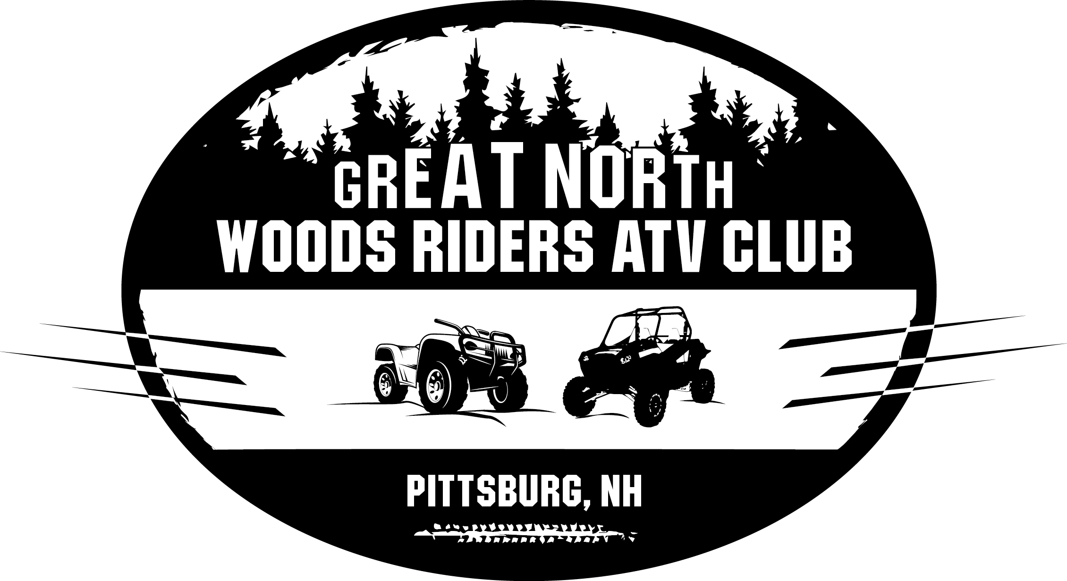

**PO Box 218**

**Pittsburg, NH 03592**

**January 1, 2025 – December 31, 2025**

**Membership is available online at www.greatnorthwoodsridersatv.org**

Member Name: ___________________________________________________________________________

Name and address must be the same as on driver’s license that machine is registered to.

2nd Adult Member (over 18 living in same household): ________________________________

Mailing Address:

___________________________________________________________________________

City, State, Zip:

___________________________________________________________________________

Phone: _______________________________

Email address **(please print clearly)**: ____________________________________________

Do you prefer your membership voucher: emailed_____ mailed_____ both______

Do you want to become a member of NH Off Highway Vehicle Association (NHOHVA) for free? Yes ______ No ______

|  |  |
| --- | --- |
| **Club Membership**  Single or Family Membership $40.00 ________  **Club Business Sponsorship**  Bronze Sponsor $100.00____________  Silver Sponsor $250.00____________  Gold Sponsor $500.00 ___________  Platinum Sponsor $1,000.00 ____________  Donation $ _____________  Total: $ _____________  ^Sponsorship **DOES NOT** include a membership voucher. | Please make checks payable to:  GNWR ATV Club  PO Box 218  Pittsburg, NH 03592  [gnwratvclub@gmail.com](mailto:gnwratvclub@gmail.com)  [www.greatnorthwoodsridersatv.org](http://www.greatnorthwoodsridersatv.org)  [www.facebook.com/GNWRAC](http://www.facebook.com/GNWRAC)  Like us on facebook |